Task 1
Numbers and Variables
- Create three variables
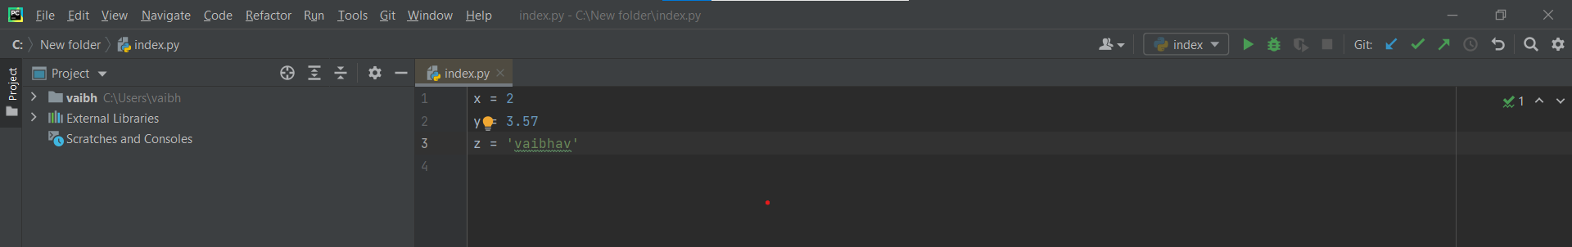

- Create a variable of type complex and swap it with another variable type integer.
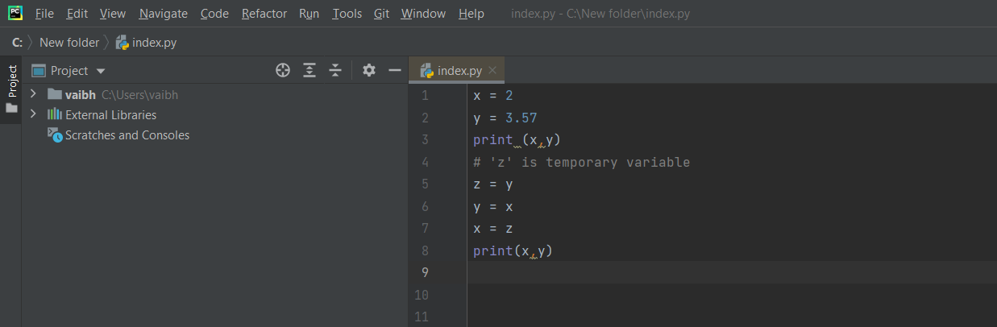
- Swapping variable using 3rd variable and swapping without 3rd variable
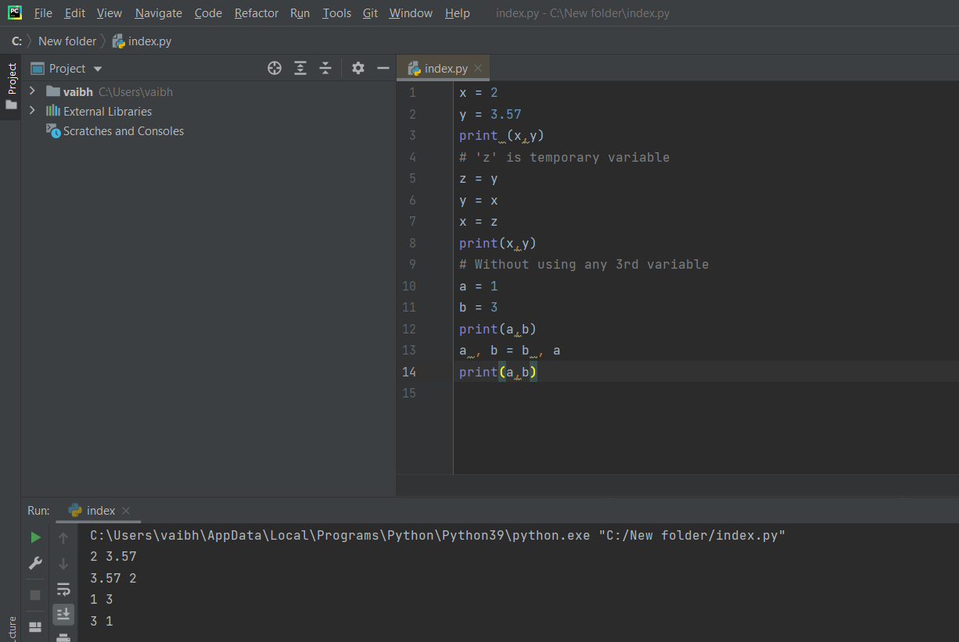
- Write program that takes input from the user and print it using both python 2 and python3

Python 2
Message = int(raw_input(“please enter int value: ”))
Print(Message)
Python 3
Message = int(input(“please enter int value:”))
Print(Message)

- Write a program to complete task given below.
Ask user to enter 2 numbers in between 1-10, add the two numbers and keep the sum in another variable called z. add 30 to z and store the output in variable result and print result as the final output.
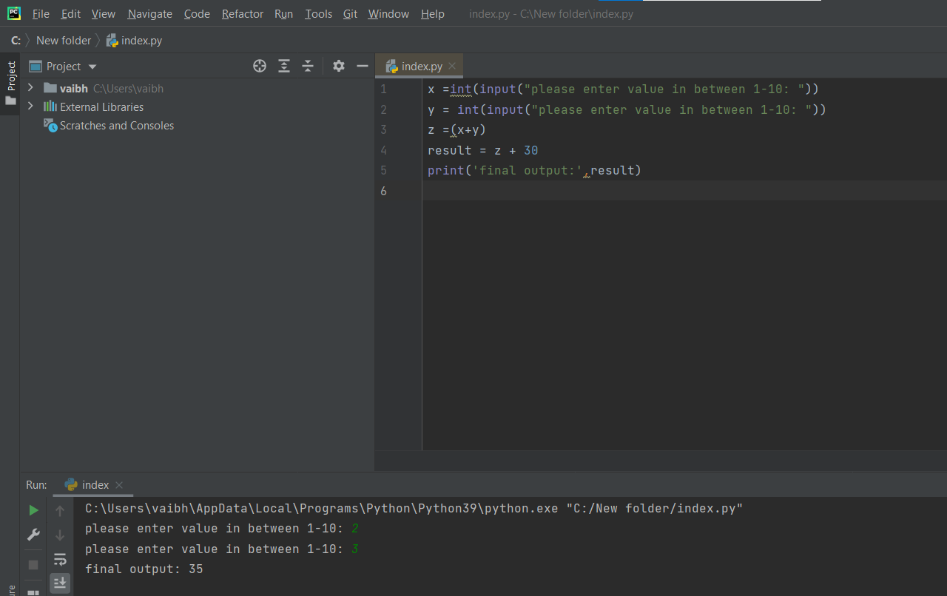
- Write a program to check the data type of the entered values.
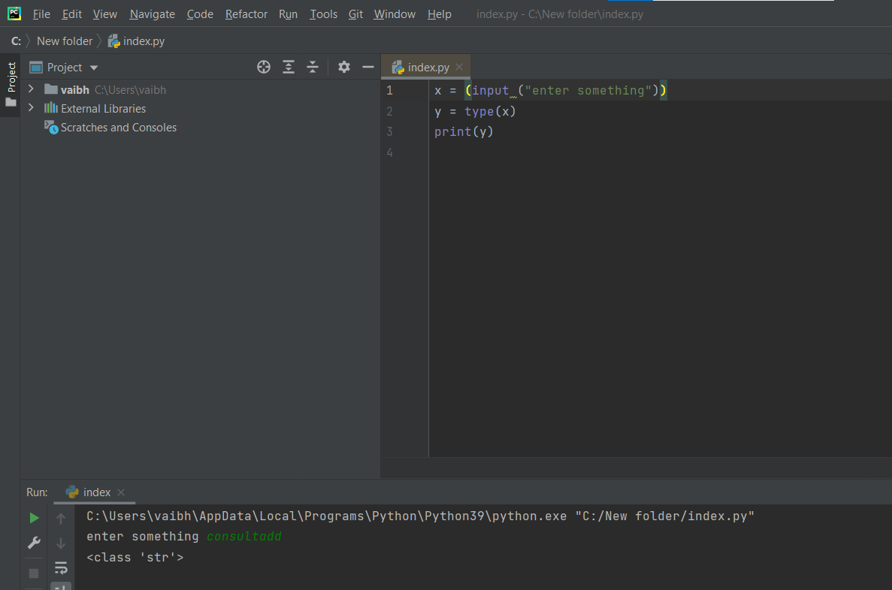
- Create a variable using format such as Upper Camel Case, Lower Camel Case, Snake case and UPPER CASE.
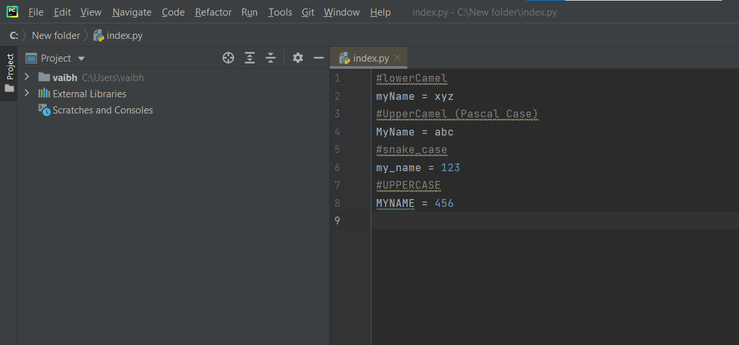
- If one data type value is assigned to “a” variable and then a different data type value is assigned to “a” again. Will it change the value? If yes then why?
Yes the variable value is change just because we can not store more the one value at the same place so when we assign new value to the variable the old value will be deleted and stored new value.

Task 2
Operators and Decision-Making Statements

- Write a program in python to perform the following operations:
If a number is divisible by 3 it should print “consultadd” as a string
If a number is divisible by 5 it should print “python training” as a string
If a number is divisible by 3 and 5 both it should print “consultadd-python training” as a string
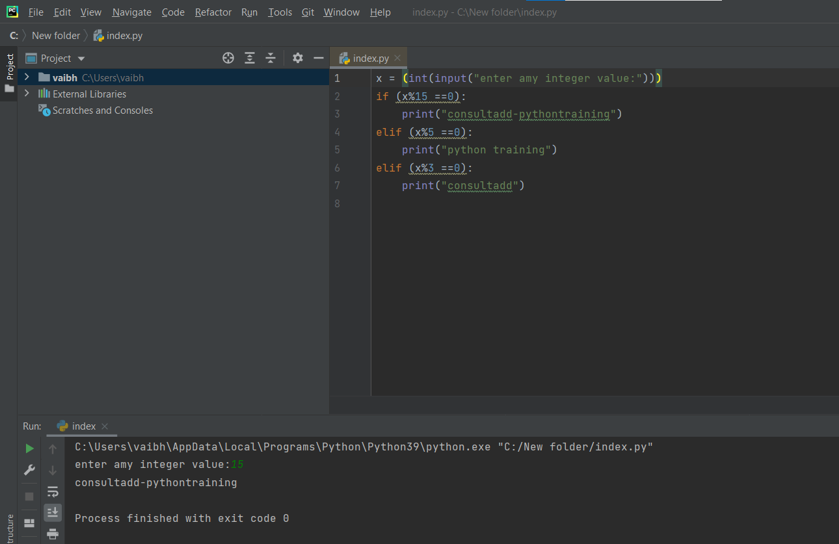

- Write a program in python to perform the following operator-based task:
Ask user to choose the following option first:
- If user enter 1: addition
- If user enter 2: subtraction
- If user enter 3: division
- If user enter 4: Multiplication
- If user enter 5: Average
Ask user to enter two values and keep those number in variable name num1 and num2 respectively for the first 4 options mention above.
Ask the user to enter two more value numbers as first and second for calculating the average as soon as the user chooses an option 5.
At the end if the answer of any options is negative print a statement saying “NEGATIVE”
NOTE: at a time, user can only perform one action.

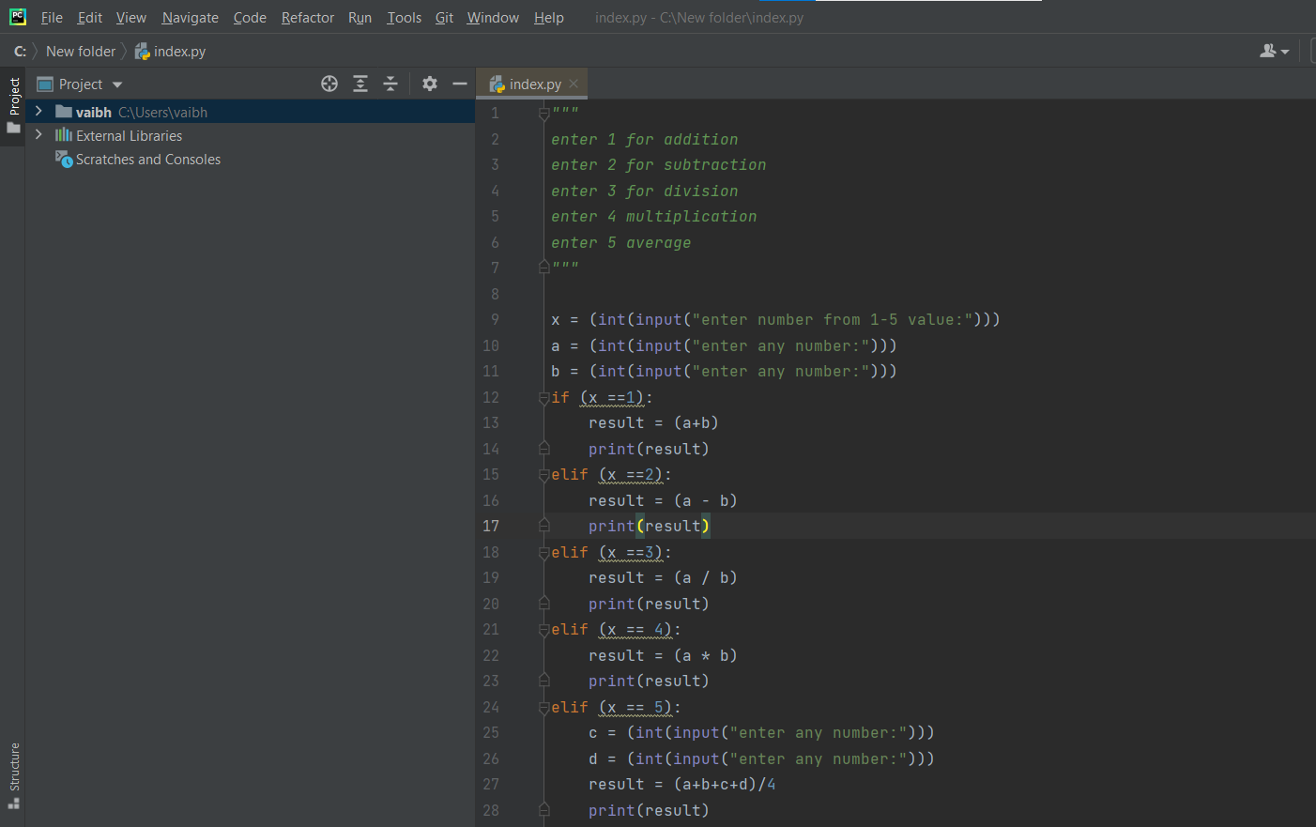
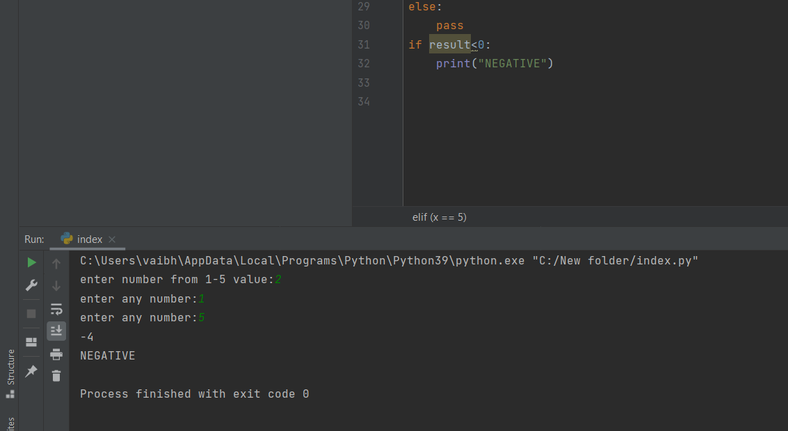
- Write a program in python to implement the given flowchart:
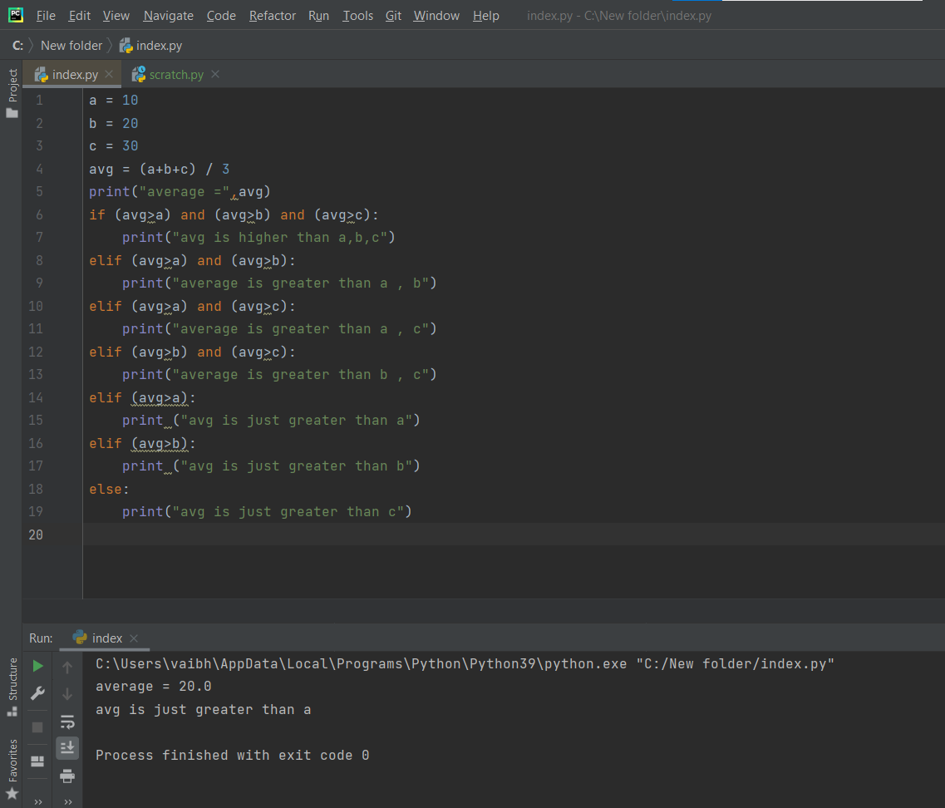
- Write a program to break and continue if the following cases occurs.
If the user enter the negative value just break the loop and print “it’s over”
If the user enters a positive number just continue the loop and print “good going”

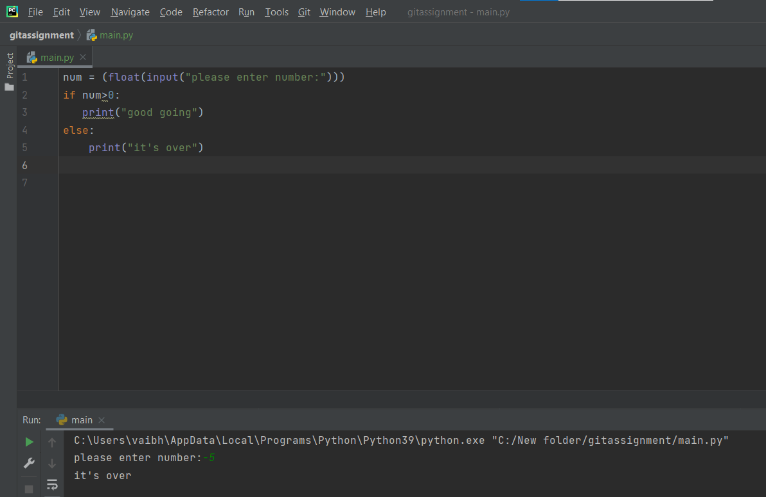

- Write a program in python which will find all such members which are divisible by 7 but are not a multiple of 5, between 2000 and 3200.
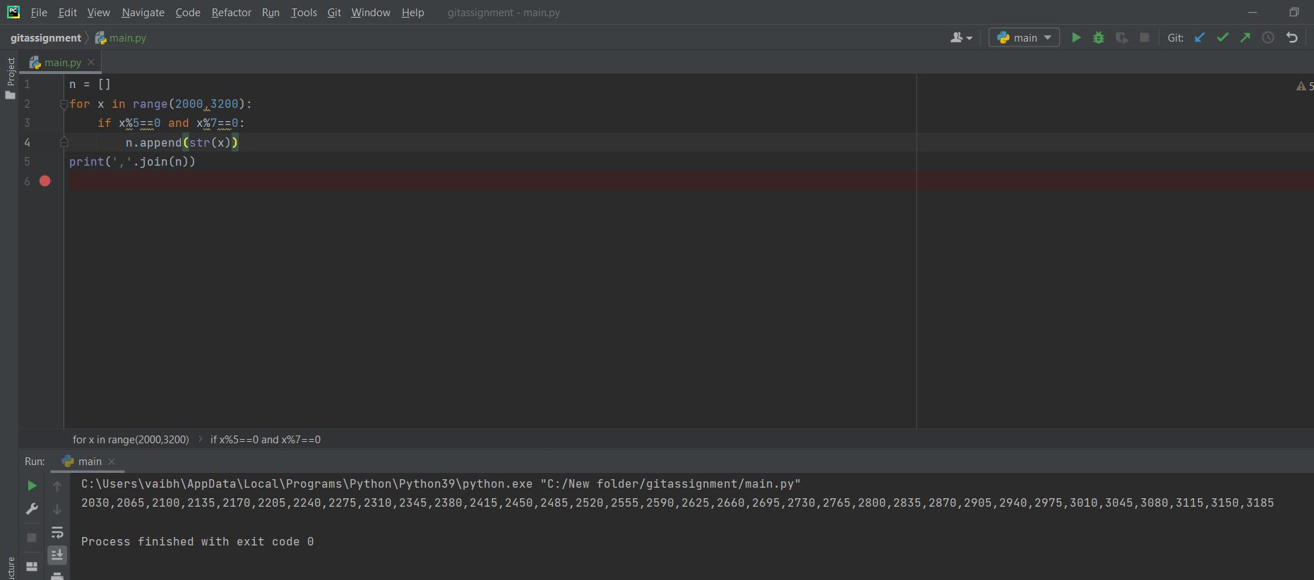

- What is the output of the following code example.

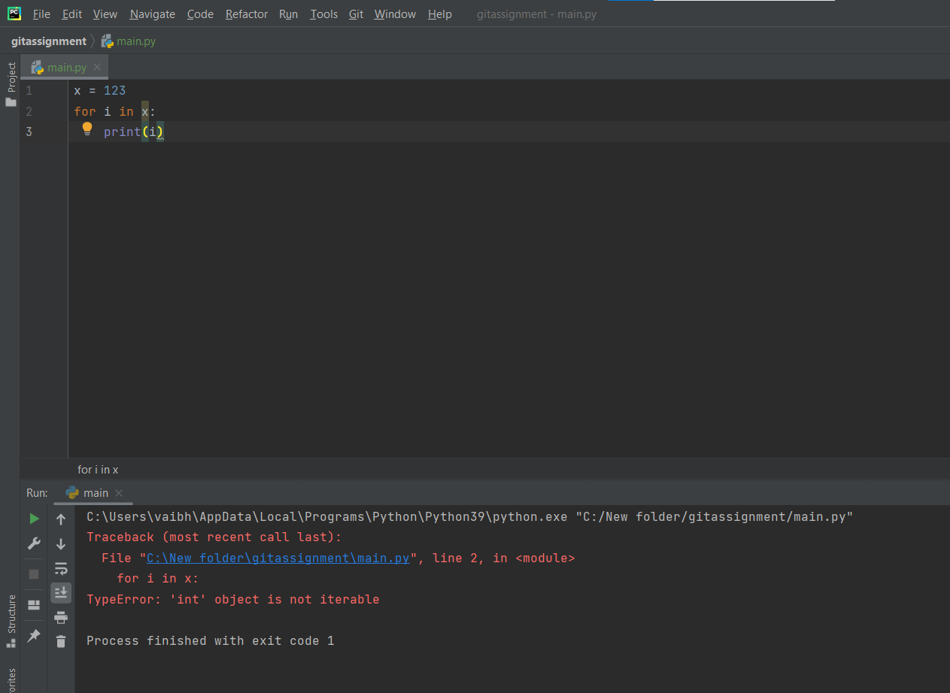

- 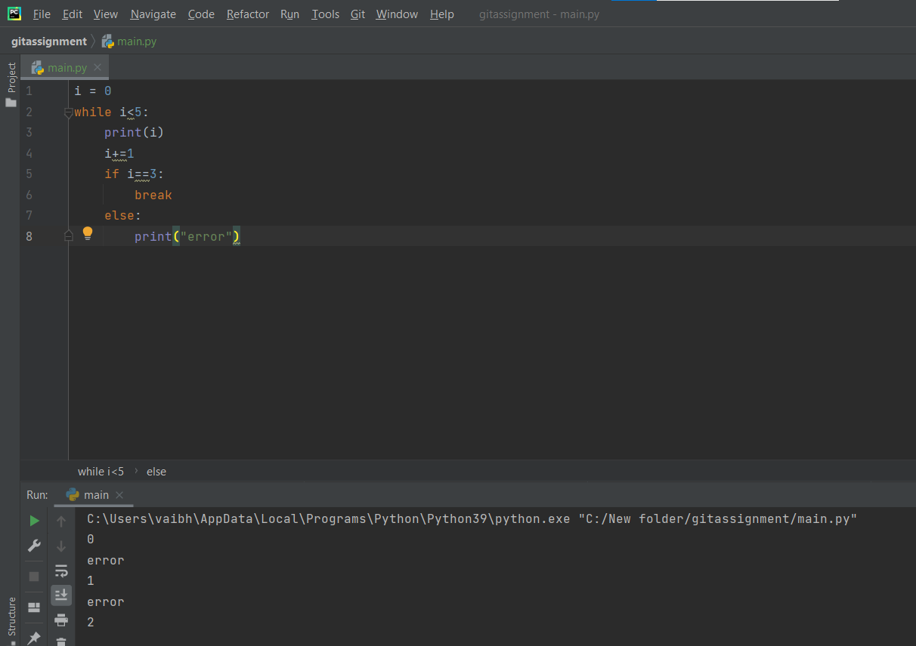

- 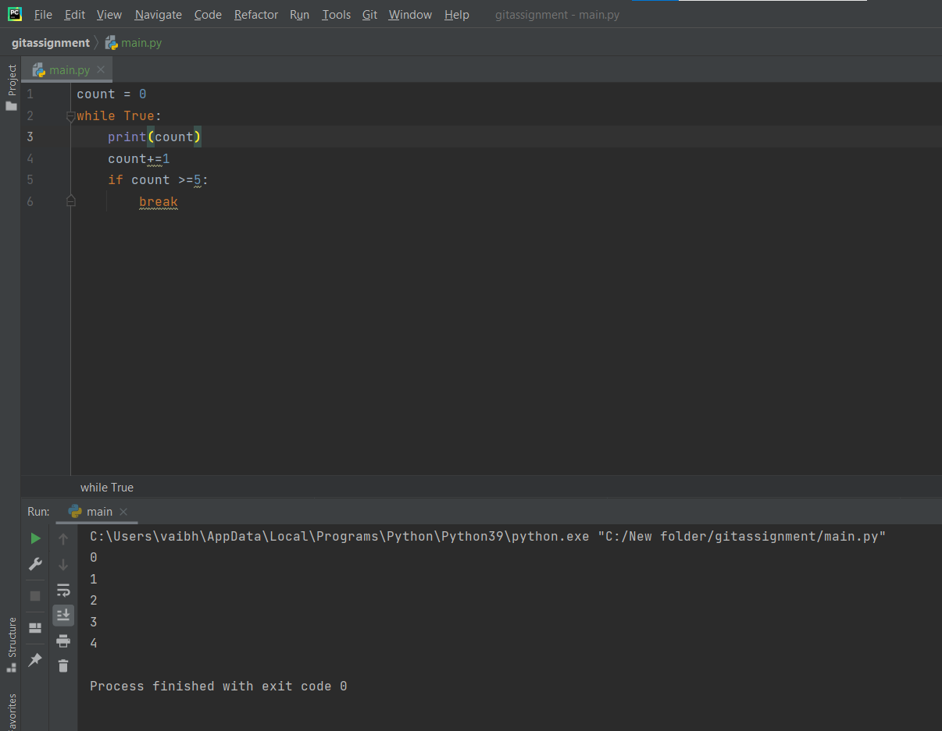

- Write a program that prints all the numbers from 0 to 6 except 3 and 6.
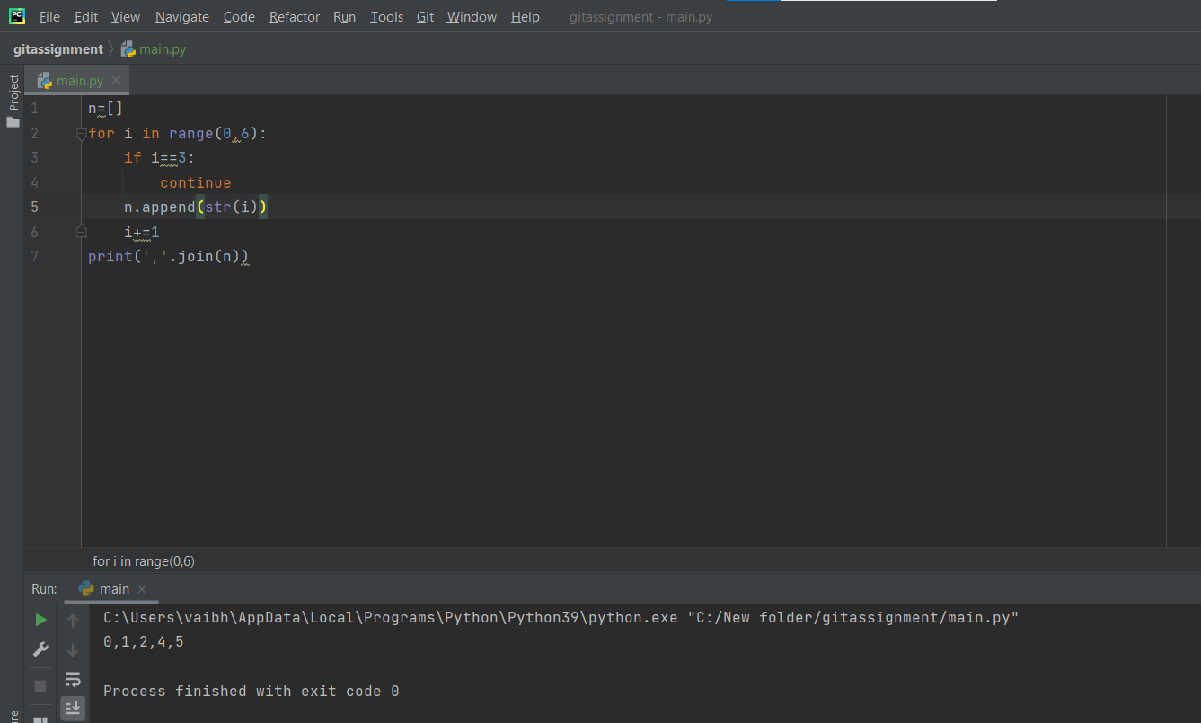
- Write a program that accept strings as an input from the user and calculate the number of digits and letters.
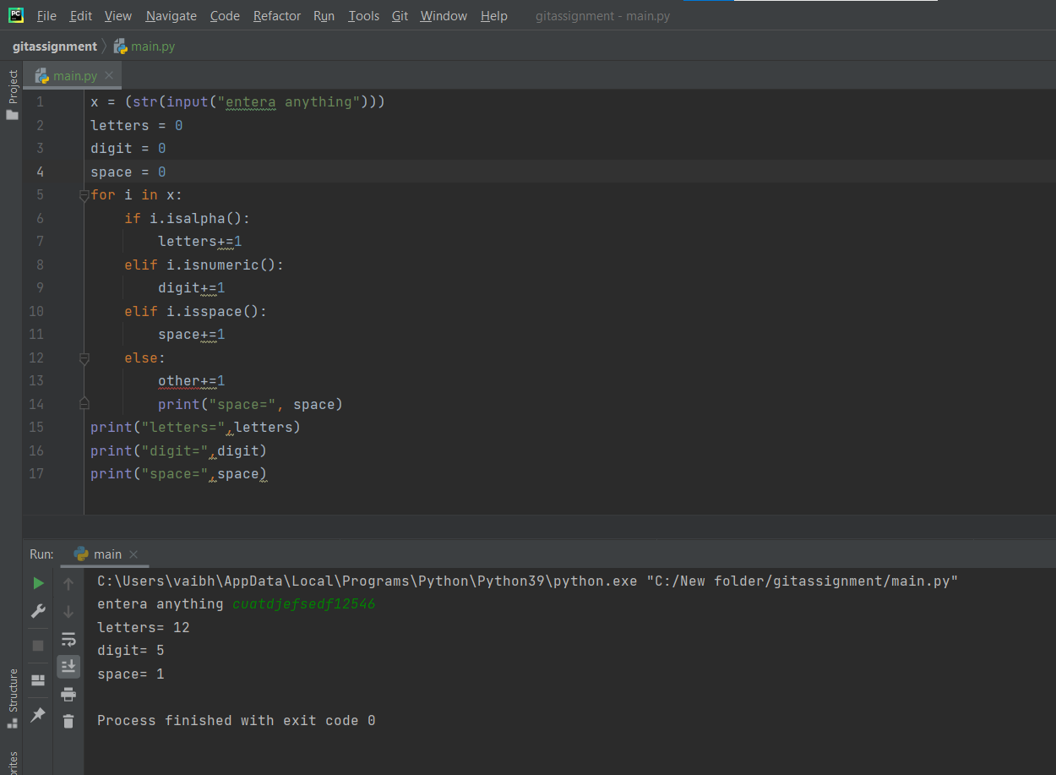
- Read two parts of the question below:

Write a program such that it asks users to “guess the lucky number”. If the correct number is guessed the program stops, otherwise it continues forever.
Modify the program so that it asks users whether they want to guess again each time. Use two
variables, ‘number’ for the number and ‘answer’ for the answer to the question whether they want
to continue guessing. The program stops if the user guesses the correct number or answers “no”. (
The program continues as long as a user has not answered “no” and has not guessed the correct
number)
for correct guessing output:
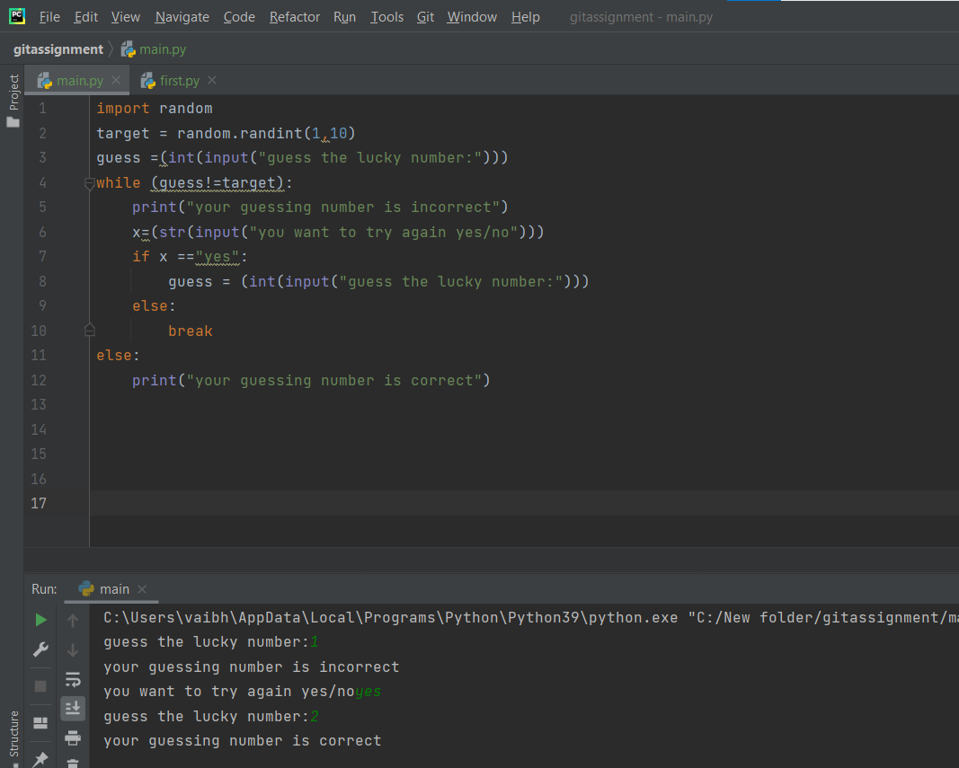

- Write a program that asks five times to guess the lucky number. Use a while loop and a counter,
such as
counter = 1
While counter <= 5:
print(“Type in the”, counter, “number”
counter=counter+1
The program asks for five guesses (no matter whether the correct number was guessed or not). If the
correct number is guessed, the program outputs “Good guess!”, otherwise it outputs “Try again!”.
After the fifth guess it stops and prints “Game over!”.
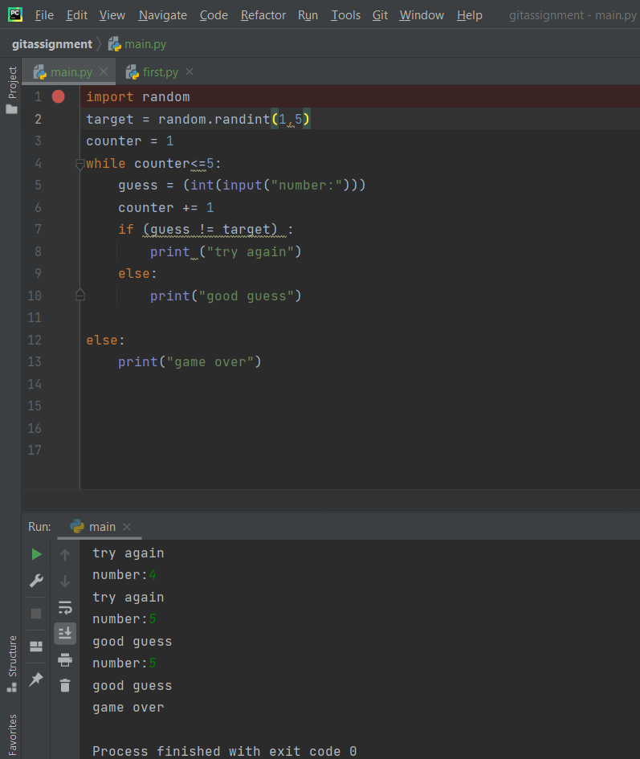

- In the previous question, insert break after the “Good guess!” print statement. break will terminate the while loop so that users do not have to continue guessing after they found the number. If the user does not guess the number at all, print “Sorry but that was not very successful”.
